Java example
The following example is in the Java programming language, and shows how the contents of a tree of nodes (in this case describing the components of a car) can be printed. Instead of creating "print" methods for each subclass (Wheel, Engine, Body, and Car), a single class (CarElementPrintVisitor) performs the required printing action. Because different subclasses require slightly different actions to print properly, CarElementDoVisitor dispatches actions based on the class of the argument passed to it.
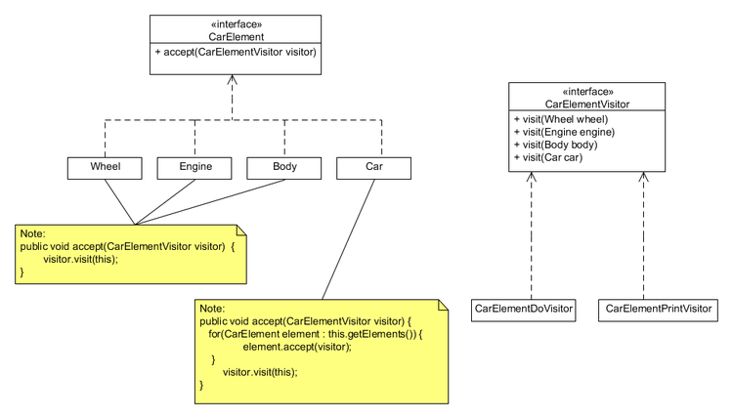
interface CarElementVisitor {
void visit(Wheel wheel);
void visit(Engine engine);
void visit(Body body);
void visit(Car car);
}

interface CarElement {
void accept(CarElementVisitor visitor); // CarElements have to provide accept().
}

class Wheel implements CarElement {
private String name;

public Wheel(String name) {
this.name = name;
}

public String getName() {
return this.name;
}

public void accept(CarElementVisitor visitor) {
visitor.visit(this);
}
}

class Engine implements CarElement {
public void accept(CarElementVisitor visitor) {
visitor.visit(this);
}
}

class Body implements CarElement {
public void accept(CarElementVisitor visitor) {
visitor.visit(this);
}
}

class Car implements CarElement {
CarElement[] elements;

public CarElement[] getElements() {
return elements.clone(); // Return a copy of the array of references.
}

public Car() {
this.elements = new CarElement[]
{ new Wheel("front left"), new Wheel("front right"),
new Wheel("back left") , new Wheel("back right"),
new Body(), new Engine() };
}

public void accept(CarElementVisitor visitor) {
for(CarElement element : this.getElements()) {
element.accept(visitor);
}
visitor.visit(this);
}
}

class CarElementPrintVisitor implements CarElementVisitor {
public void visit(Wheel wheel) {
System.out.println("Visiting " + wheel.getName()
+ " wheel");
}

public void visit(Engine engine) {
System.out.println("Visiting engine");
}

public void visit(Body body) {
System.out.println("Visiting body");
}

public void visit(Car car) {
System.out.println("Visiting car");
}
}

class CarElementDoVisitor implements CarElementVisitor {
public void visit(Wheel wheel) {
System.out.println("Kicking my " + wheel.getName() + " wheel");
}

public void visit(Engine engine) {
System.out.println("Starting my engine");
}

public void visit(Body body) {
System.out.println("Moving my body");
}

public void visit(Car car) {
System.out.println("Starting my car");
}
}

public class VisitorDemo {
static public void main(String[] args) {
Car car = new Car();
car.accept(new CarElementPrintVisitor());
car.accept(new CarElementDoVisitor());
}
}

